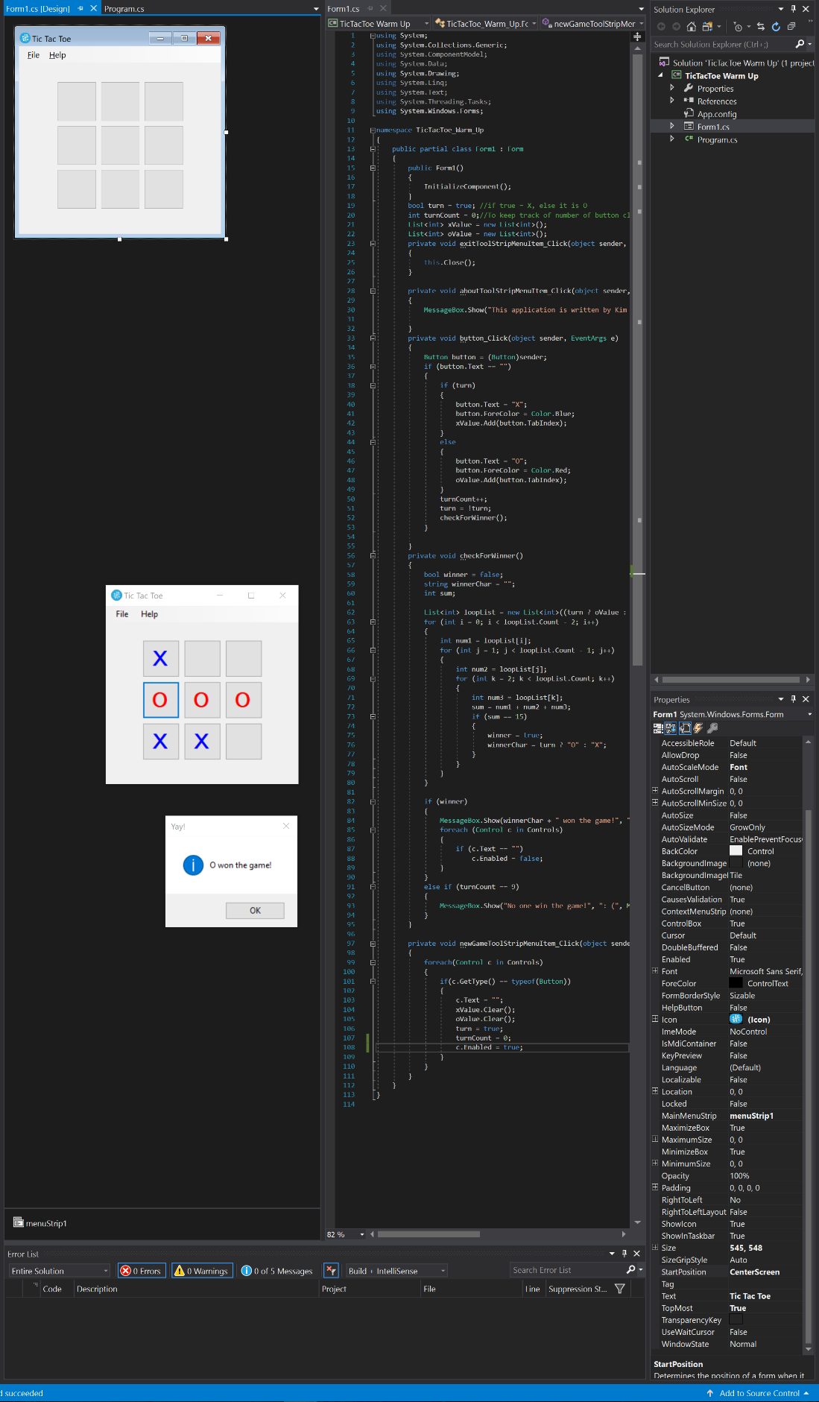Snapshot of Visual Studio environment:

Method to check for winner:

|  |  |  |
| --- | --- | --- |
| button1  8 | button2  1 | button3  6 |
|
| button4  3 | button5  5 | button6  7 |
|
| button7  4 | button8  9 | button9  2 |
|

The black word in each cell is the name of the button respectively. The red number in each cell is its tableIndex.

The way I assigned the table index this way is to make the sum of any 3 numbers in a row, column or diagonal is equal to 15.

Based on this idea, to check the winner, each time a button is clicked, if the text of this button is x, then the value of table index will be added to an int list called xValue. Otherwise, if the text of this button is o, the value of its table index will be added to list called oValue.

And then, nested loop is used to determine if there are any 3 numbers in the list that add up to 15. If there is, then related string char will be the winner.

Code:

using System;

using System.Collections.Generic;

using System.ComponentModel;

using System.Data;

using System.Drawing;

using System.Linq;

using System.Text;

using System.Threading.Tasks;

using System.Windows.Forms;

namespace TicTacToe_Warm_Up

{

public partial class Form1 : Form

{

public Form1()

{

InitializeComponent();

}

bool turn = true; //if true = X, else it is O

int turnCount = 0;//To keep track of number of button clicked

List<int> xValue = new List<int>();

List<int> oValue = new List<int>();

private void exitToolStripMenuItem_Click(object sender, EventArgs e)

{

this.Close();

}

private void aboutToolStripMenuItem_Click(object sender, EventArgs e)

{

MessageBox.Show("This application is written by Kim Yang","About",MessageBoxButtons.OK);

}

private void button_Click(object sender, EventArgs e)

{

Button button = (Button)sender;

if (button.Text == "")

{

if (turn)

{

button.Text = "X";

button.ForeColor = Color.Blue;

xValue.Add(button.TabIndex);

}

else

{

button.Text = "O";

button.ForeColor = Color.Red;

oValue.Add(button.TabIndex);

}

turnCount++;

turn = !turn;

checkForWinner();

}

}

private void checkForWinner()

{

bool winner = false;

string winnerChar = "";

int sum;

List<int> loopList = new List<int>((turn ? oValue : xValue));

for (int i = 0; i < loopList.Count - 2; i++)

{

int num1 = loopList[i];

for (int j = 1; j < loopList.Count - 1; j++)

{

int num2 = loopList[j];

for (int k = 2; k < loopList.Count; k++)

{

int num3 = loopList[k];

sum = num1 + num2 + num3;

if (sum == 15)

{

winner = true;

winnerChar = turn ? "O" : "X";

}

}

}

}

if (winner)

{

MessageBox.Show(winnerChar + " won the game!", "Yay!", MessageBoxButtons.OK, MessageBoxIcon.Information);

foreach (Control c in Controls)

{

if (c.Text == "")

c.Enabled = false;

}

}

else if (turnCount == 9)

{

MessageBox.Show("No one win the game!", ": (", MessageBoxButtons.OK);

}

}

private void newGameToolStripMenuItem_Click(object sender, EventArgs e)

{

foreach(Control c in Controls)

{

if(c.GetType() == typeof(Button))

{

c.Text = "";

xValue.Clear();

oValue.Clear();

turn = true;

turnCount = 0;

c.Enabled = true;

}

}

}

}

}